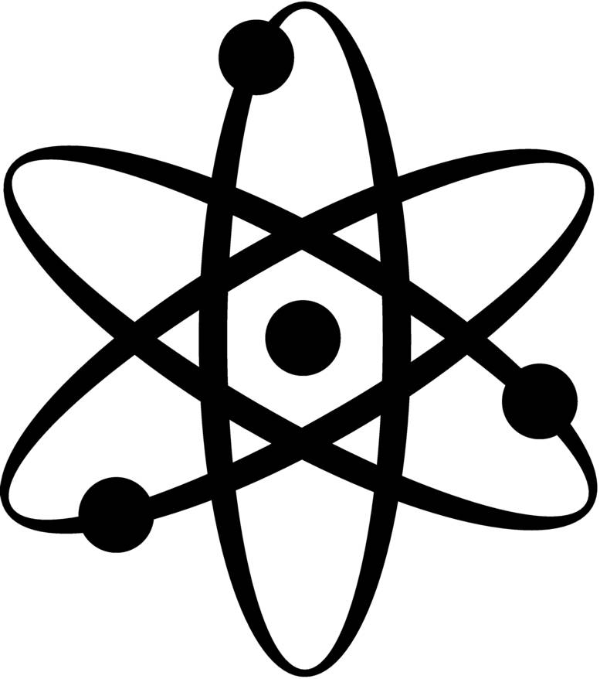
Name __________________________

Modern Chemistry
Introduction to the Textbook

Your textbook is designed and organized to make learning as logical as possible. In this introductory worksheet, you will be looking at how your book is organized as well as becoming familiar with some of the extra features that will help you find the information you need.

1.) Look at the table of contents in the front of your book. How many chapters are in your textbook?

2.) What is the title of Chapter 14?

3.) What sort of information is found on pages xxii - xxvii? (I know... Roman numerals are confusing. Just look at the beginning of your book)

4.) Skim through pages xxix - xxxix (yep... more Roman numerals). According to your textbook, what are the 7 secrets for success in chemistry?

a.

b.

c.

d.
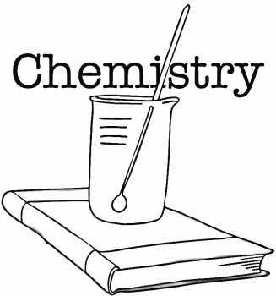
e.

f.

g.

* Here’s another interesting little secret. Years ago, a study was done which yielded interesting results. Groups of students were told they were part of a study to research teacher behavior. Half of the groups were asked to send signals of boredom and disinterest (slumping in chairs; no eye contact; doodling; etc...). The other half of the study group was asked to pretend they were very interested (sit up straight; make eye contact; nod their heads; etc...). The students thought they were involved in a study about how this behavior would change the way the teacher taught, but in reality they were the actual test subjects. The results really aren’t surprising. Of course the students who pretended to be interested scored significantly higher when tested over the materials. Give it a try!

5.) OK... enough of those “Roman numeral” pages of the book. Let’s take a look at the “real” subject matter of chemistry. Turn to page 1 of your textbook. Oh wait... there is no page 1 (I have no idea why). Turn to the chapter intro of chapter 1 (pages 2 - 3). What is the title of this chapter?

6.) Chapter 1 is divided into 3 smaller sections. What are the titles of these 3 sections?

a.

b.

c.

7.) Each chapter section contains “Main Ideas”. What are the 2 main ideas of Chapter 1 - Section 1?

a.

b.

8.) Turn to Chapter 1 - Section 2. Each section begins with a listing of “Key Terms” for the section.

a. What is the 4th key term of the first column of this list?

b. Find this word in the text. What makes these key terms easy to find?

c. The key terms are defined in blue. What is the definition of this word?

9.) Most chapters will contain some real life examples which illustrate how chemistry is involved in our every day lives. Look at page 15. Using chemistry, a professor has begun to solve the mystery of what high quality musical instruments?

10.) What chapter feature is found on page 22?

11.) Many chapters have a “Careers in Chemistry” section. What chemistry career is discussed in Chapter 7?

12.) Pictures and their captions often convey very important information. Look at page 658. Based on Figure 4.2 why are nuclear power plants usually located next to bodies of water?

13.) The back of your textbook contains extensive reference sections. What is Appendix A about?

14.) The glossary is also a useful tool to find definitions for chemical terms. Use the glossary in your book to define the term “Malleability”.

15.) The index can also be used to quickly find where a topic is discussed within the book. Use your index to find out where ibuprofen is discussed, and then answer the following question:

a. What is the chemical formula for ibuprofen?

16.) Inside the back cover is a tool that you will use throughout the year in chemistry. What is this tool called?
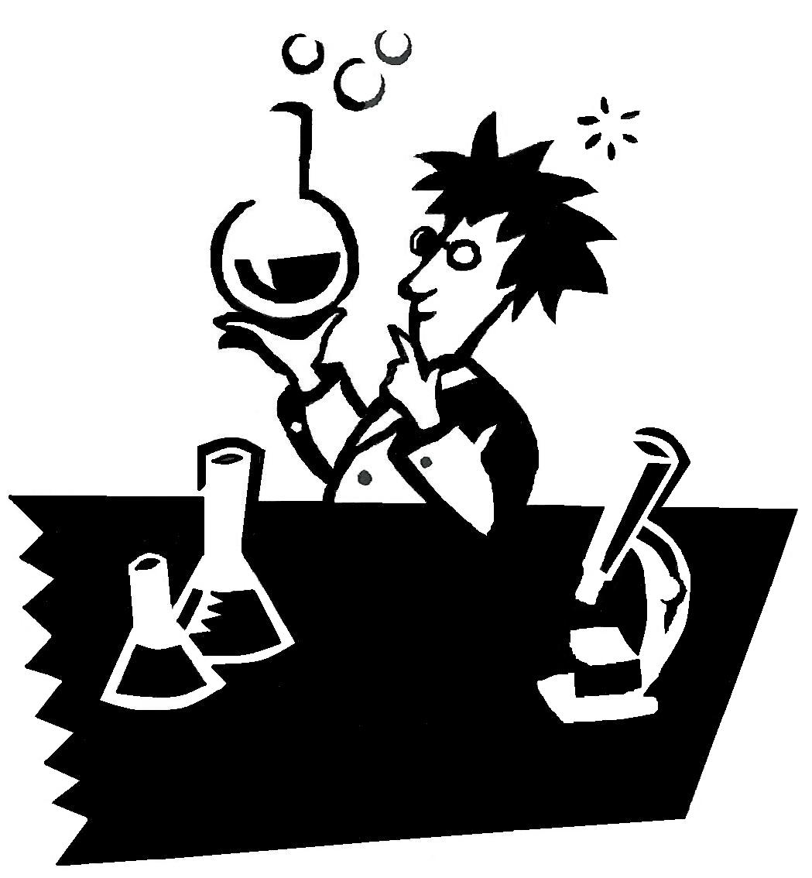

Remember throughout the year that your textbook is a tool
of learning that contains many useful features. Use it wisely
and it can help you learn the materials of the course in the
most efficient way.

